### **ShockWaveKickers User Guide**

### **Frontend**

frontend components exist in App -> Views

**Backend**

Backend components: App -> Controllers where APIs are called.

Schema is defined in schema.rb under config folder

**How to deploy to run and deploy code in Heroku from scratch:**

1. Fork the repo: <https://github.com/Lightfoot-Heavy-Machinery/shockwave_kickers>
2. If you wanna create gmail account instead of using [shockwavekickers606@gmail.com](mailto:shockwavekickers606@gmail.com),
   1. Create the account
   2. Follow the steps to generate app code: <https://support.google.com/mail/answer/185833?hl=en>
   3. Update heroku app config with SENDMAIL_PASSWORD
      1. If you plan to create a new Heroku, save this so that use it in next steps
   4. To test locally, follow the ***Send Email Confirmation for new user locally*** section
3. If you want to integrate new AWS account instead of using the older AWS account linked with [shockwavekickers606@gmail.com](mailto:shockwavekickers606@gmail.com)
   1. Create S3 bucket and IAM role only (following: <https://medium.com/@rmg007/rails-6-0-upload-images-using-active-storage-and-amazon-simple-storage-service-amazon-s3-36861c03dc4a>)
   2. Go to local terminal, Create new rails master key: <https://gist.github.com/db0sch/19c321cbc727917bc0e12849a7565af9>
   3. Call the following command “EDITOR="vim" bin/rails credentials:edit” (**Mac command**) or “SET EDITOR=”code” bin/rails credentials:edit” (**Windows command**)
   4. Get Access Key and Secret Key of the IAM user in AWS
   5. Add Access Key and Secret Key in the file and save the file. **Should encrypt and save the access key and secret key**

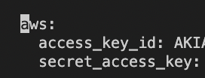

* 1. In storage.yml under config folder, update the S3 bucket name with the name of the S3 created
  2. To test locally, look at ***Store images in S3 instead of locally while developing*** section

1. New Heroku account set up steps if you don’t the want to use the older Heroku account linked with [shockwavekickers606@gmail.com](mailto:shockwavekickers606@gmail.com) (password is with client: Professor Lightfoot):
   1. Create Heroku account under student plan (<https://www.heroku.com/github-students/signup> )
      1. Create a Heroku app
      2. Create postgres mini db and upgrade web server to dyno eco plan
      3. Add the following webpacks

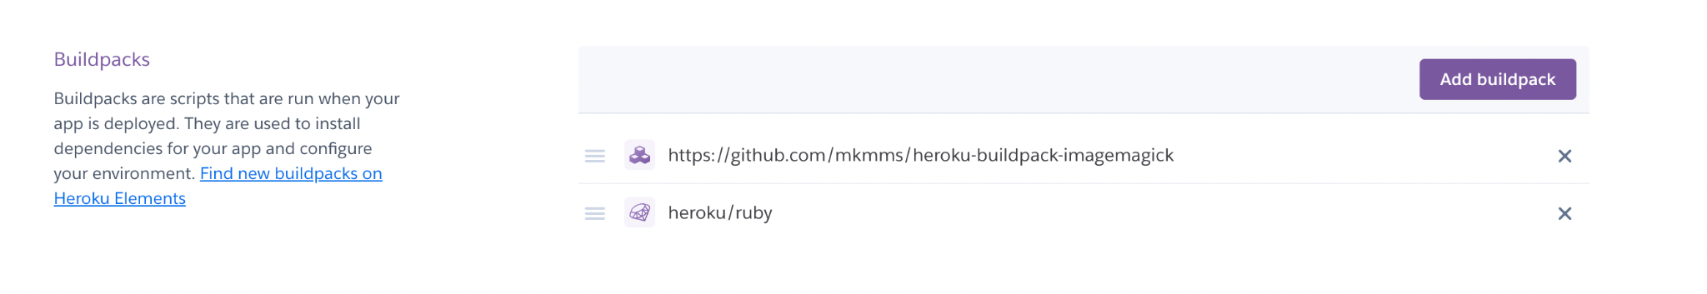

* + 1. Copy var config from shockwave kickers heroku account (DATABASE_URL will be different, URL of your postgres instance)

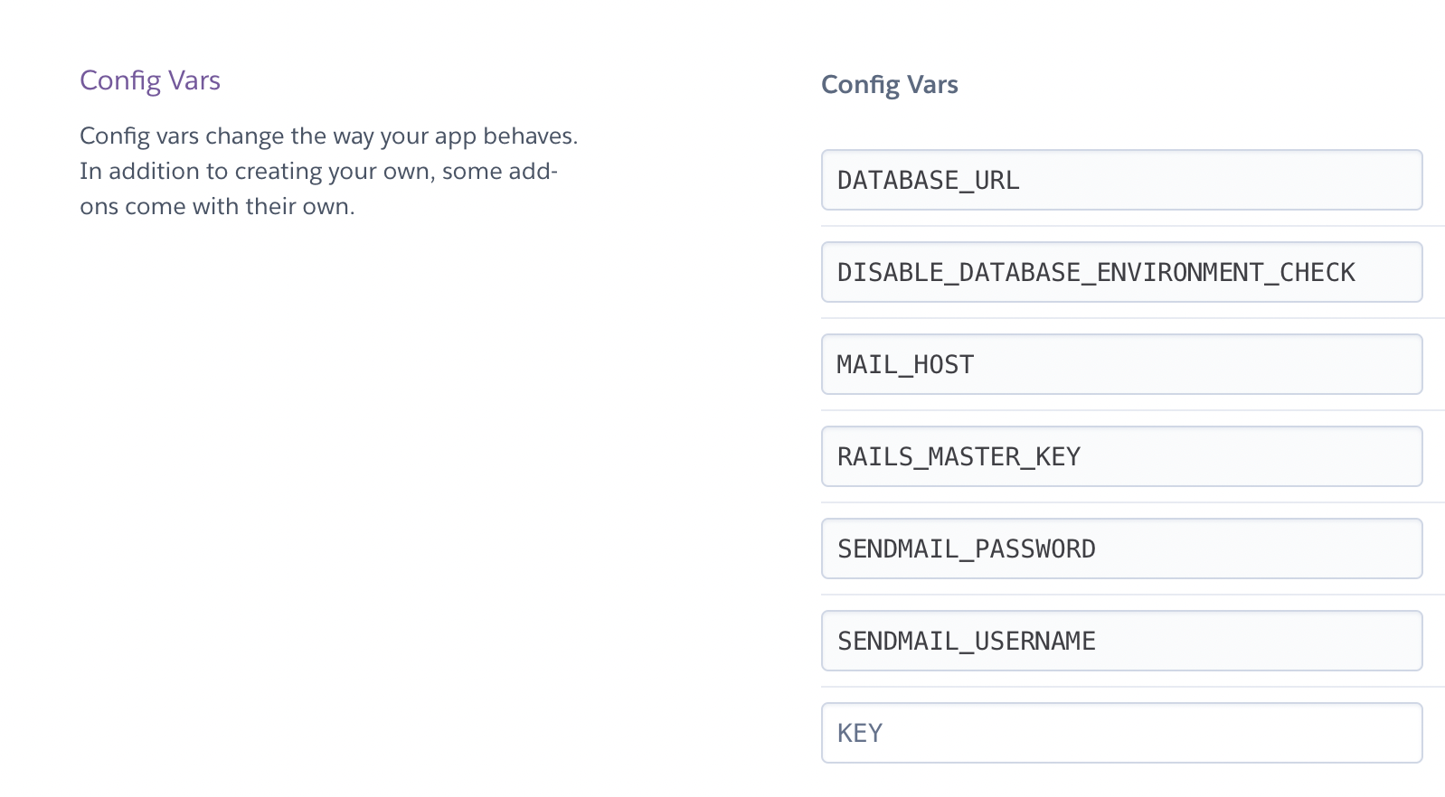

* + 1. For locally (easier way), Login into Heroku and deploy Heroku app
       - <https://devcenter.heroku.com/articles/getting-started-with-rails6#deploy-your-application-to-heroku>
    2. In forked repo, to enable CI/CD pipeline to push heroku production
       - Update heroku api key in github repository secrets
         * Found here in correct repo: <https://github.com/Lightfoot-Heavy-Machinery/shockwave_kickers/settings/secrets/actions>
       - If the name of the Heroku app changed,
         * Change app name and email of the Heroku account

<https://github.com/Lightfoot-Heavy-Machinery/shockwave_kickers/blob/d03629c9ed35d37c8a0a5a67cbf0aa0cd91346a2/.github/workflows/build.yml#L61>

**First Time User Guide to Run Server Locally**

1. Install dependencies. Follow ***First Windows User Installation*** for Windows users and Follow ***First User Mac User Installation Local*** for Mac users
2. Run rails local instance. “Rails s” is the command
3. Your terminal should begin running the application, then giving a link that says: *http://127.0.0.1:3000*
   1. Control + left click to open the application in the browser.

**First Time Windows User Installation:**

1. INSTALLATION

Open powershell or IDE of your choice (VsCode will be sufficient)

* 1. Install Ruby: <https://www.ruby-lang.org/en/downloads/> (version 3.1.2+)
     1. Go through the installation instructions
  2. Install Rails:
     1. Type “gem install rails” in the terminal window (make sure that you are running with administrative privileges) (Rails 7.0.4+)
  3. Install Postgresql: <https://www.postgresql.org/download/windows/> (v 14.1+)
     1. Go through the installation instructions
     2. WRITE DOWN YOUR PASSWORD CREDS
  4. Install ImageMagick: <https://imagemagick.org/script/download.php> (v 7.1.0+)
     1. Go through the installation instructions

1. STARTUP
   1. Git clone <https://github.com/Lightfoot-Heavy-Machinery/shockwave_kickers>
   2. Go into app/config/database.yml inside of the code
      1. Change the username and password values to the one that corresponds to YOUR credentials
      2. save.
   3. Open a ruby or powershell terminal, then run “bundle install”
   4. Run the pgAdmin4 application
   5. To setup (or update) the rails database, type the following:
      1. “Rake db:create”
      2. “Rake db:migrate”
      3. “Rake db:seed”
      4. “bundle exec rake assets:precompile”

**First User Mac User Installation Local**

1. To Install Ruby, Rails and Bundler, followed this: <https://www.digitalocean.com/community/tutorials/how-to-install-ruby-on-rails-with-rbenv-on-macos>
   * Rails version 7.0.4+
   * Ruby version 3.1.2+
2. To Install imagemagick: brew install imagemagick
   * v 7.1.0+
3. To install Postgres: brew install postgresql
   * v 14.1+
4. Start Postgres each time at login: brew services start postgresql
5. Bundle install all the gems: bundle install
6. Database initialization
   * rake db:create
   * rake db:migrate
7. To load all the assets with latest css and bootstrap:
   * bundle exec rake assets:precompile

**Start the local instance**

Rails s

**Run test unit cases**

Rails test

This command should also store test coverage. To open coverage:

* + open coverage/index.html

#### 

#### 

#### 

#### 

#### **Other Guides**

#### **Store images in S3 instead of locally while developing**

1. Go to development.rb and update: config.active_storage.service = :amazon
2. Go to storage.yml, change amazon bucket name to *shockwavekickers-dev*
3. Export RAILS_MASTER_KEY=LOOK_AT_HEROKU_VAR_CONFIG
4. Run rails server start command

**Send Email Confirmation for new user locally**

1. Export environment variables locally

export SENDMAIL_PASSWORD=”xyz”

export SENDMAIL_USERNAME=shockwavekickers606@gmail.com

export MAIL_HOST=gmail.com

1. You should get email confirmation for user sign up